BRICK BREAKER GAME

Using Javascript

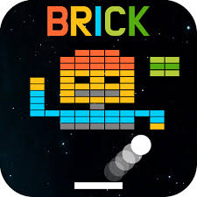

Project Report By,

GAURI GARG

CSIT

1900290110034

**ABSTRACT/INTRODUCTION**

The Brick Breaker is about breaking the breaks with the help of bonucing ball and sliding plane. You can play the game until you are able to break all the bricks without dropping the ball to the ground. The player has to move the sliding plane using arrow keys. The player wins the game if he/she is able to clear all the bricks in 3 lives.

**TECHNOLOGY/FRAMEWORK**

* HTML
* CSS
* JAVASCRIPT

The PC controls of this game are also simple. You just have to use the left, right, up, and down keys to move the sliding plane according to their requirements.

**UML DIAGRAM**

